**Open Ended Lab**

**Name: Basharat Ahmad.**

**Reg Number: 2019104.**

**Section: “B”.**

**Subject: PH-101 Lab.**

**Instructors:**

**(1) Asim Ullah PhD Scholar (FES). (2) Bilal Ahmad Lecturer (FES).**

**Topic: Compound Pendulum.**

**Compound Pendulum**

**Objective:**

**To determine the value of “g” by using a Compound Pendulum.**

**Theory:**

**In previous classes we see that a simple pendulum was used to determine the value of “g”. A simple pendulum consist of a bob and unstreachable massless string. The string one side is attach to a fixed rigid point up in air and other to the bob. But the main fault in it is that it’s not practical for anybody because in real life the string is not massless and all the time weight is not down ward. So we use Compound Pendulum to find value of “g” of anybody in real life.**

**Apparatus Required:**

* **Metal Rod with holes in it.**
* **Meter rod.**
* **Stop watch.**
* **Mounted Razor Blade.**
* G clamp V shape knife edge**.**
* Permanent Marker.

**Construction:**

**Normally the metal rod used in Compound pendulum for experimental purpose is 1m long, consist of 19 holes and the 10 hole is its midpoint. All the holes are 0.05m away from the nearest hole. Now we construct it in following steps:**

1. **Measure the Metal rod with the meter rod to find its midpoint.**
2. **Mark this midpoint with the permanent marker so that we could identify it’s midpoint easily.**
3. **Insert G clamp V sharp knife edge in the 1st hole of the metal rod which is at 0.45m away from the mid hole (or) point.**
4. **Put G clamp V sharp knife edge inserted in the metal rod on Mounted Razor Blade in such a way that it’s sharp edge is on it.**
5. **Stop watch is used to note its time reading.**

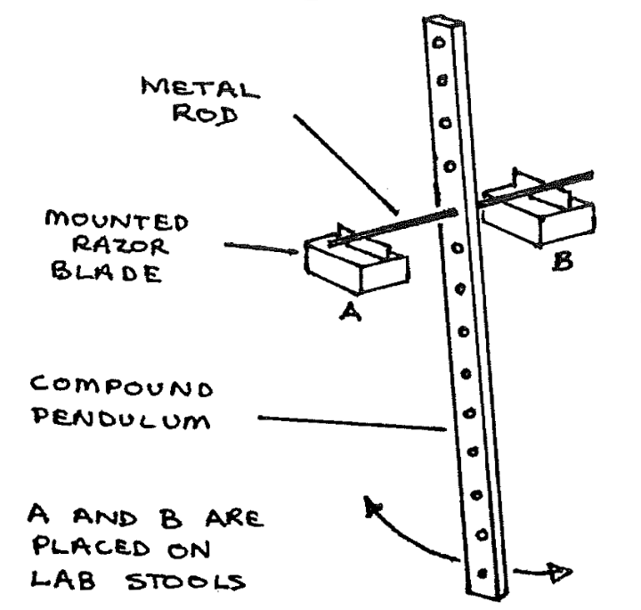**Now our required Compound Pendulum is ready as shown in fig.**

**Working:**

1. **Take a reference on the wall with marker i.e. its starting point “A” means from where you will start your metal rod to oscillate, its midpoint “C” of oscillation and its end point “B”.**
2. We suspended the pendulum vertically by resting the knife edge at end A of the wall.
3. **It will oscillate between A and B.**
4. **Note the time for ten oscillations of the metal rod on stop watch.**
5. **Repeat the process two time for each hole.**
6. We fixed the knife edges successively in various holes on each side of mid hole (or) midpoint. And in each case we measure the time for 10 oscillations and the distance of the knife edges from mid hole (or) midpoint.
7. **Note all the reading in a table.**
8. **Now find time average of the two times by adding the two times and dividing it by 2.**
9. **At last divide the time by 10 and we get the time period.**

**Mathematically :**

The weight “mg” causes a restoring torque which is given by

$T_{z}=-mglsinθ$------------------------(1)

The negative sign shows that the restoring torque produced is in clockwise direction.

When the metal rod is released at its extreme position, it oscillates but about its equilibrium position. The motion is not simple harmonic because the torque ${"T}_{z}"$ is proportional to “sinθ” rather than to “θ” itself. However, for small “θ”, we can approximate “sin θ” by “θ” in radians, just as we did in analysing simple pendulum. Then the motion is simple harmonic so equation (1) becomes

$T_{z}=-mglθ$---------------------(2)

Also we know that

$T_{z}=Iα$----------------------(3)

Comparing (2) and (3), we get

$Iα=$ $-mglθ$-----------------(4)

$I\frac{d^{2}θ}{{dt}^{2}}=-mglθ$

$\frac{d^{2}θ}{{dt}^{2}}=-\frac{mglθ}{I}$---------------------------(5)

Which is comparable with simple harmonic equation, a=- $ω^{2}x$

Means that ω = $\sqrt{\frac{mgl}{I}}$, so the angular frequency is

$$f=\frac{1}{2π}\sqrt{\frac{mgl}{I}}$$

So $T=2π\sqrt{\frac{I}{mgl}}$----------------------------------------(6)

Where “I” is moment of inertia through the point of suspension.

Equation (6) can be used to find the period of the bar pendulum when we are familiar with moment of inertia of the bar.

Similarly we can find the moment of inertia of irregular shaped objects by measuring time period for it experimentally.

Using parallel axis theorem, we have

$$I= I_{CM}+ ml^{2}$$

$I=m{(k)}^{2}+ ml^{2}$----------------------(7)

Putting (7) in (6), we get

$T=2π\sqrt{\frac{k^{2}+ l^{2}}{gl}}$------------------------------------(8) where k= radius of gyration.

Where L = $\frac{k^{2}+ l^{2}}{l}$

So T= $2π\sqrt{\frac{L}{g}}$-------------------------(9)

L = $\frac{l_{1}+ l_{2}}{2}$ (can be figured out from graph drawn)

$L= \frac{AB+CD}{2}$ (Can be figured out from graph)

**Table For Holes Above Midpoint:**

|  |  |  |  |  |  |  |  |  |
| --- | --- | --- | --- | --- | --- | --- | --- | --- |
| S.NO. | Hole Number | distance from Midpoint (M) | No. Of oscillations | Time For    T1 | Oscillation  T2 | Time period for 10 vibrations(t) | Time period(T=t/n) | Time period  Average |
| 1 | 1 | 0.45m | 10 | 16.71 sec | 16.69 sec | 16.70 sec | 1.670 sec | 1.710 sec |
| 2 | 2 | 0.40m | 10 | 15.66 sec | 15.76 sec | 15.70 sec | 1.570 sec | 1.710 sec |
| 3 | 3 | 0.35m | 10 | 15.00 sec | 15.00 sec | 15.00 sec | 1.500 sec | 1.710 sec |
| 4 | 4 | 0.30m | 10 | 14.59 sec | 14.61 sec | 14.60 sec | 1.460 sec | 1.710 sec |
| 5 | 5 | 0.25m | 10 | 14.59 sec | 14.61 sec | 14.60 sec | 1.460 sec | 1.710 sec |
| 6 | 6 | 0.20 m | 10 | 15.00 sec | 15.00 sec | 15.00 sec | 1.500 sec | 1.710 sec |
| 7 | 7 | 0.15 m | 10 | 16.79 sec | 16.81 sec | 16.80 sec | 1.680 sec | 1.710 sec |
| 8 | 8 | 0.10 m | 10 | 19.26 sec | 19.31 sec | 19.30 sec | 1.930 sec | 1.710 sec |
| 9 | 9 | 0.50 m | 10 | 26.99 sec | 27.01 sec | 27.00 sec | 2.700 sec | 1.710 sec |

TABLE FOR HOLES BELOW Midpoints:

|  |  |  |  |  |  |  |  |  |
| --- | --- | --- | --- | --- | --- | --- | --- | --- |
| S.NO. | Hole Number | distance from Midpoint (M) | No. Of oscillations | Time For        T1 | Oscillation      T2 | Time period for 10 vibrations(t) | Time period(T=t/n) | Time period  Average |
| 11 | 1 | -0.05 m | 10 | 26.65 sec | 27.55 sec | 27.30 sec | 2.730 sec | 1.710 sec |
| 12 | 2 | -0.10 m | 10 | 19.40 sec | 19.30 sec | 19.35 sec | 1.935 sec | 1.710 sec |
| 13 | 3 | -0.15 m | 10 | 19.69 sec | 16.94 sec | 16.80 sec | 1.680 sec | 1.710 sec |
| 14 | 4 | -0.20 m | 10 | 15.00 sec | 15.00 sec | 15.00 sec | 1.500 sec | 1.710 sec |
| 15 | 5 | -0.25 m | 10 | 14.59 sec | 14.61 sec | 14.60 sec | 1.460 sec | 1.710 sec |
| 16 | 6 | -0.30 m | 10 | 14.59 sec | 14.61 sec | 14.60 sec | 1.460 sec | 1.710 sec |
| 17 | 7 | -0.35 m | 10 | 15.00 sec | 15.00 sec | 15.00 sec | 1.500 sec | 1.710 sec |
| 18 | 8 | -0.40 m | 10 | 15.66 sec | 15.70 sec | 15.68 sec | 1.568 sec | 1.710 sec |
| 19 | 9 | -0.45 m | 10 | 16.71 sec | 16.69 sec | 16.70 sec | 1.670 sec | 1.710 sec |

**Graph from plotted table:**

**X axis = distance of suspension point from Midpoint.**

**Y axis = Time period.**

**Calculation of “g” from graph:**

|  |  |  |  |  |  |  |  |
| --- | --- | --- | --- | --- | --- | --- | --- |
| S.NO. | L1 = (AC) | L = L1 + L2  L2 = (BD) | L = (AC+BD/2) | Time(sec) | g=4 $π^{2}L/{T^{2}}$ | “g”  (average) | %Error $\frac{g1-g2}{g1}×$ 100 |
| 1 | 0.55 m | 0.55 m | 0.55 m | 2.102 sec | 10.1 m/sec | 9.73 m/sec | 0.719 % |
| 2 | 0.60 m | 0.55 m | 0.57 m | 2.401 sec | 9.36 m/sec | 9.73 m/sec | 0.719 % |

**Error Percentage %:**

The percentage error in the experiment is:

0.719 %.

**Precautions:**

1. Make sure that there is no rotational motion associated with the pendulum.

2. Stopwatch should be precise and maximum effort shall be made to make time reading

Accurate.

2. The air resistance shall be negligible in the experimental area.

**References:**

1. Physics for scientists.

2. YouTube.

3. Google for diagram.

End Of The Report